User Manual Documentation

1. **LOGIN**: user must login by navigating to login page and enter credentials given by admin and select the employee check box.

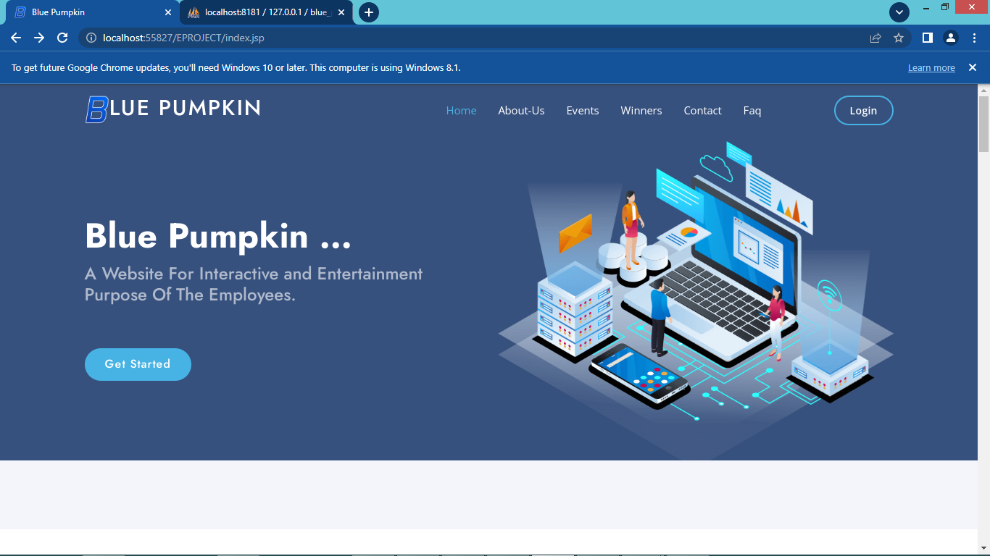

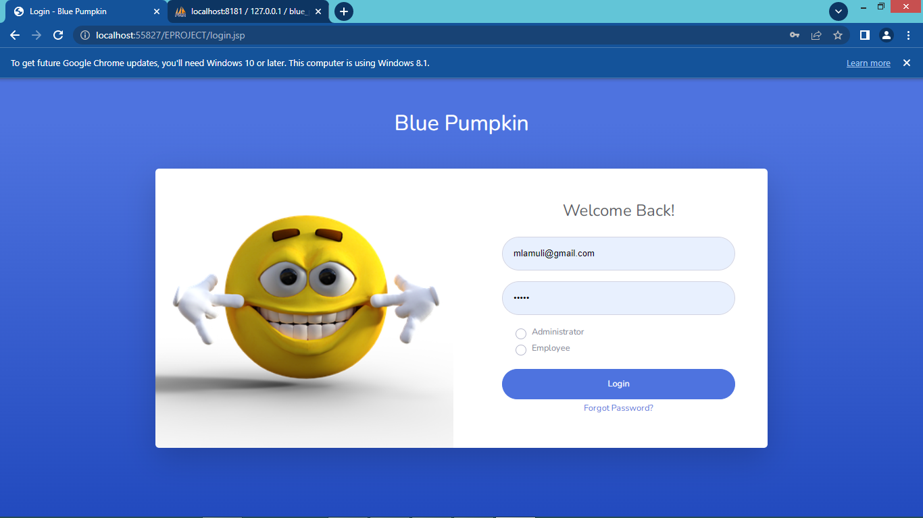

1.

2. **EVENTS**: Open event and learn more about it details.

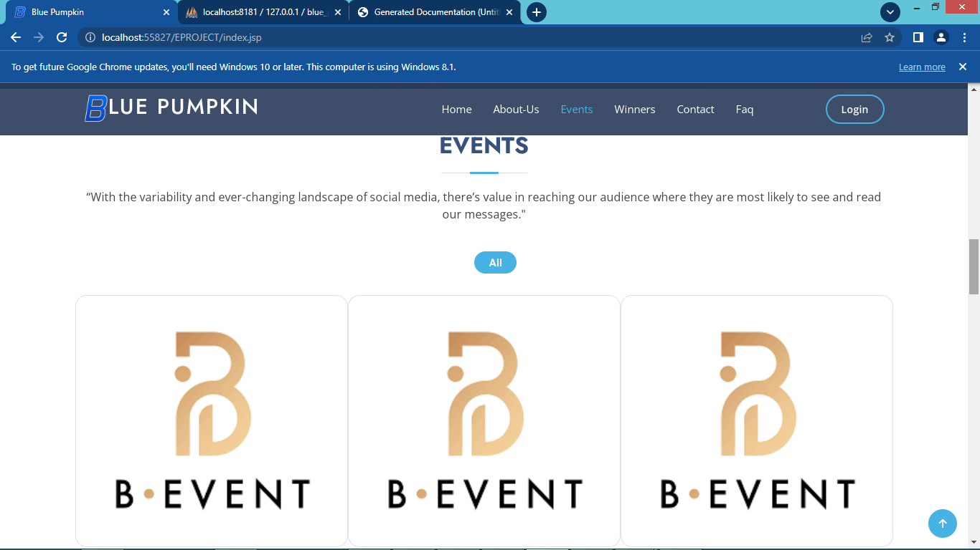

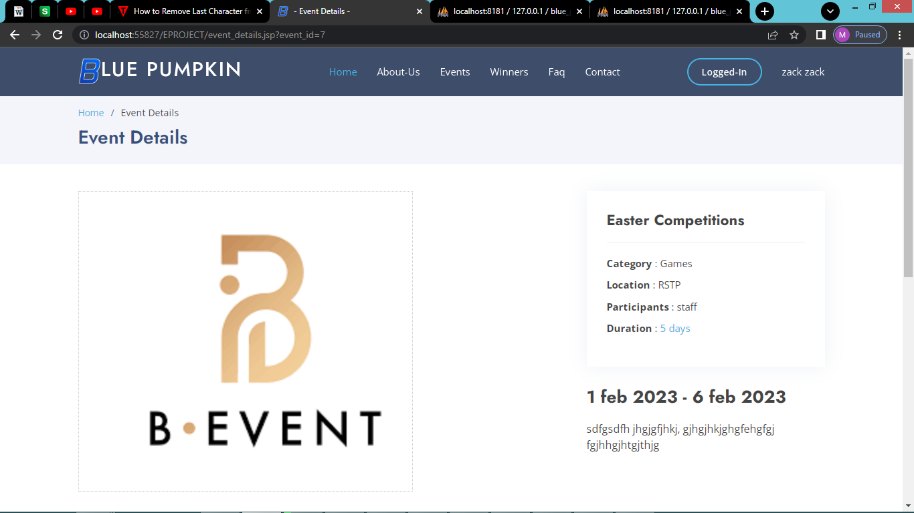

2.

3. **WINNERS: Navigate to winners**

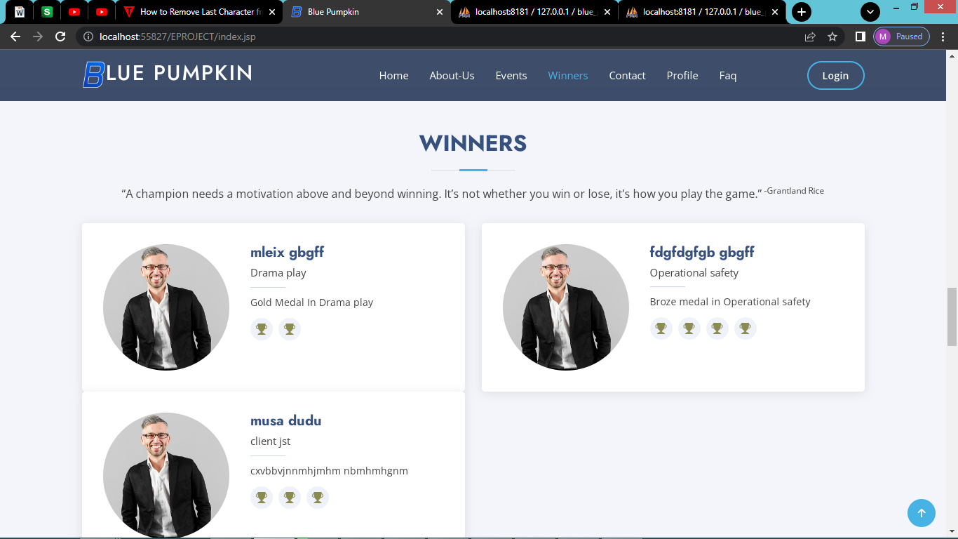

4. **CONTACTS: Navigate to contacts fill the form and send us message.**

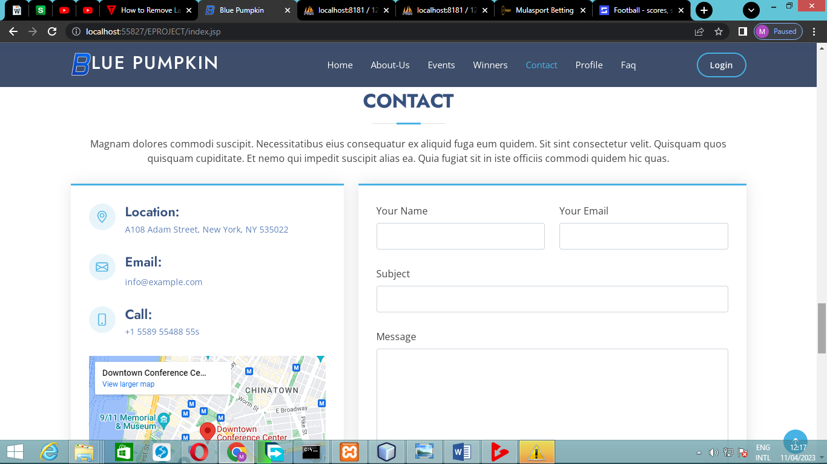

3.

5. **FAQ: Navigate to frequently asked question and click the question to expand and read answers.**

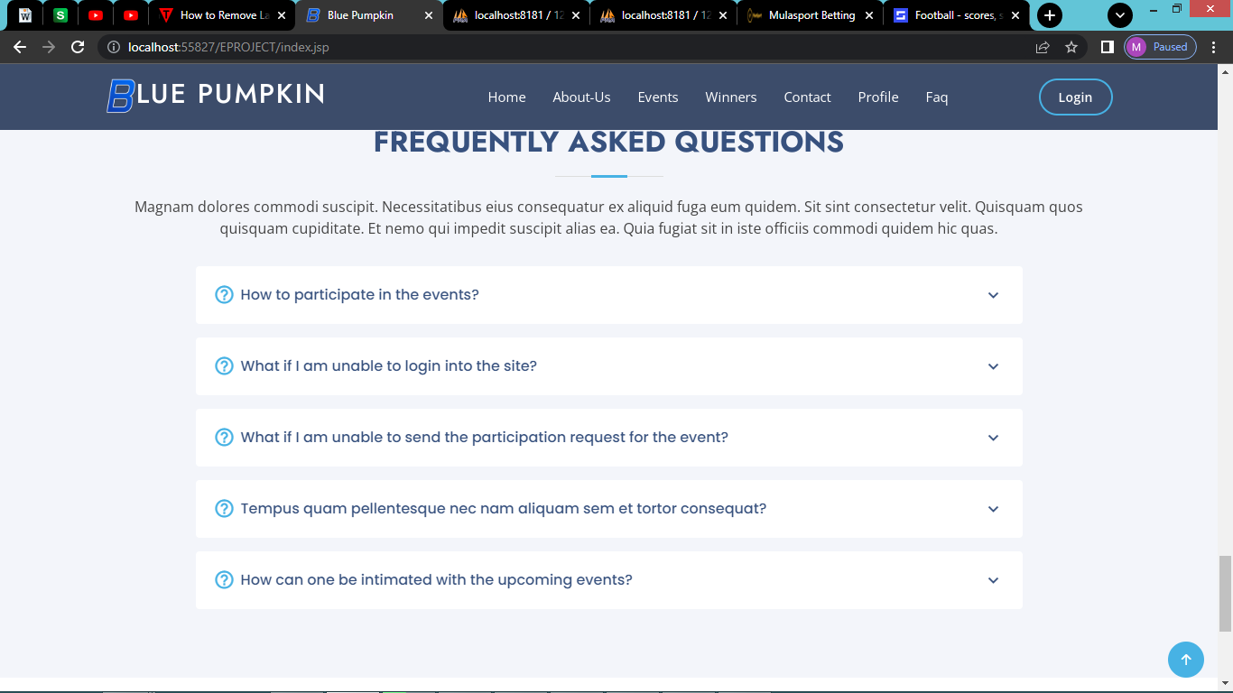

6. **TODAY “S BIRTHDAYS:** Appear when it’s someone birthday.

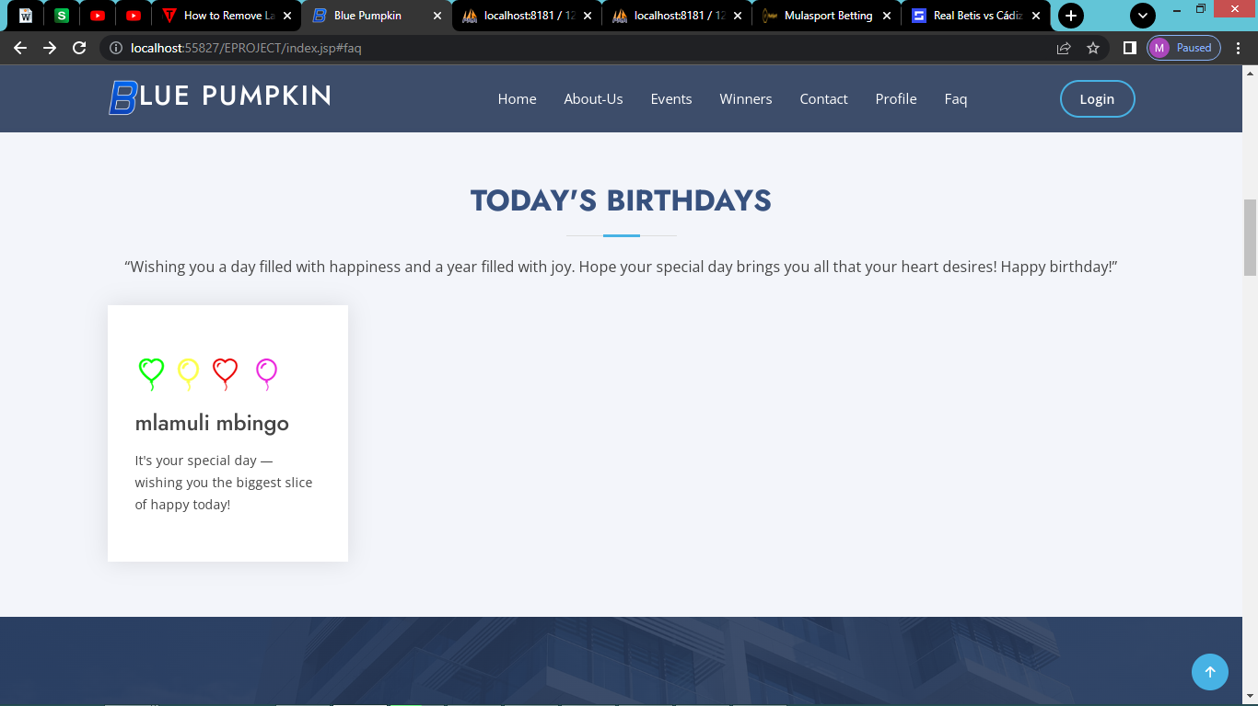

4.

7. **ABOUT US:** Navigate to about us and learn more.

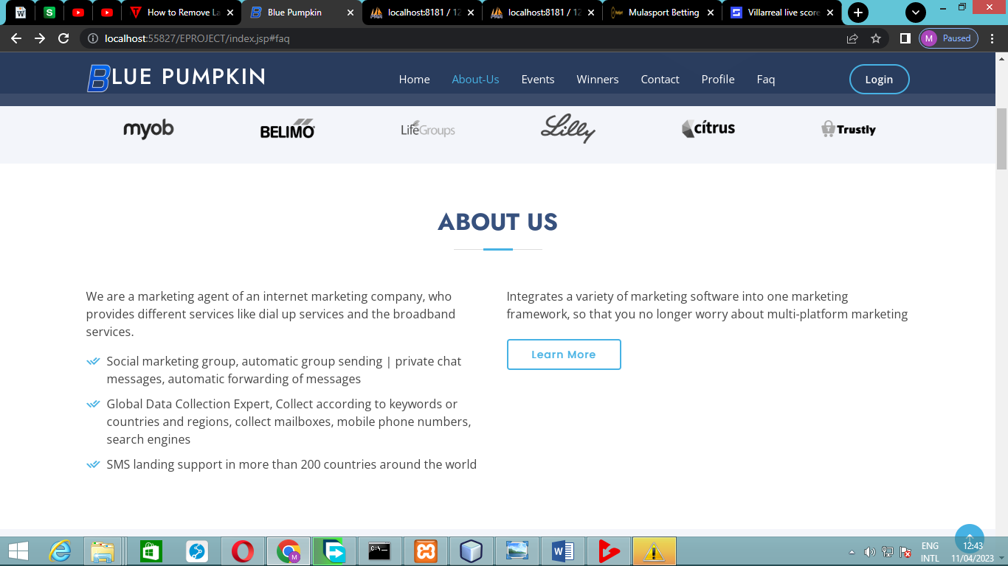

9. **PROFILE (view for employee):** Navigate to profile to add your picture and more details about you.

